https://www.youtube.com/watch?v=kbsE_kjdLKA

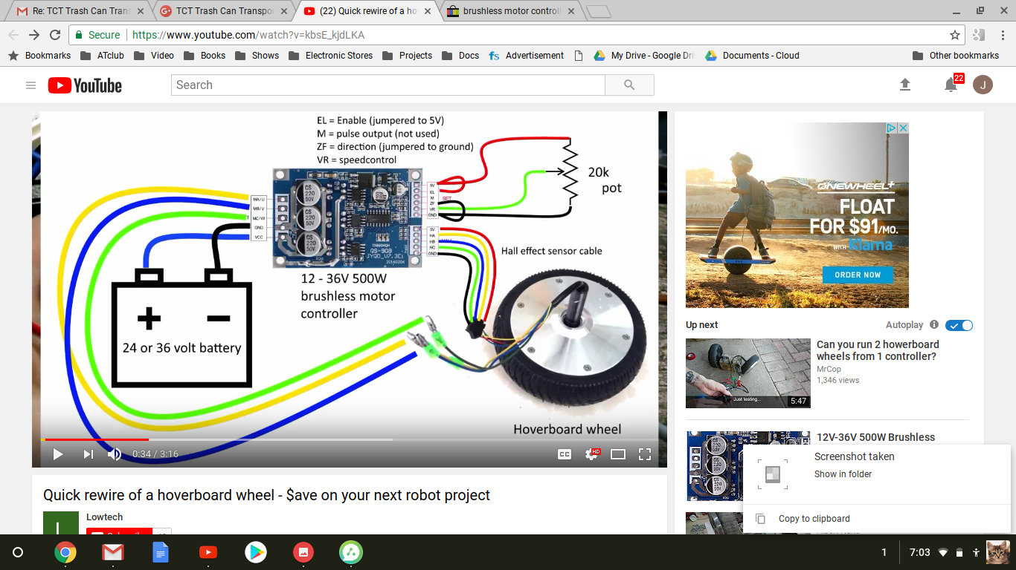

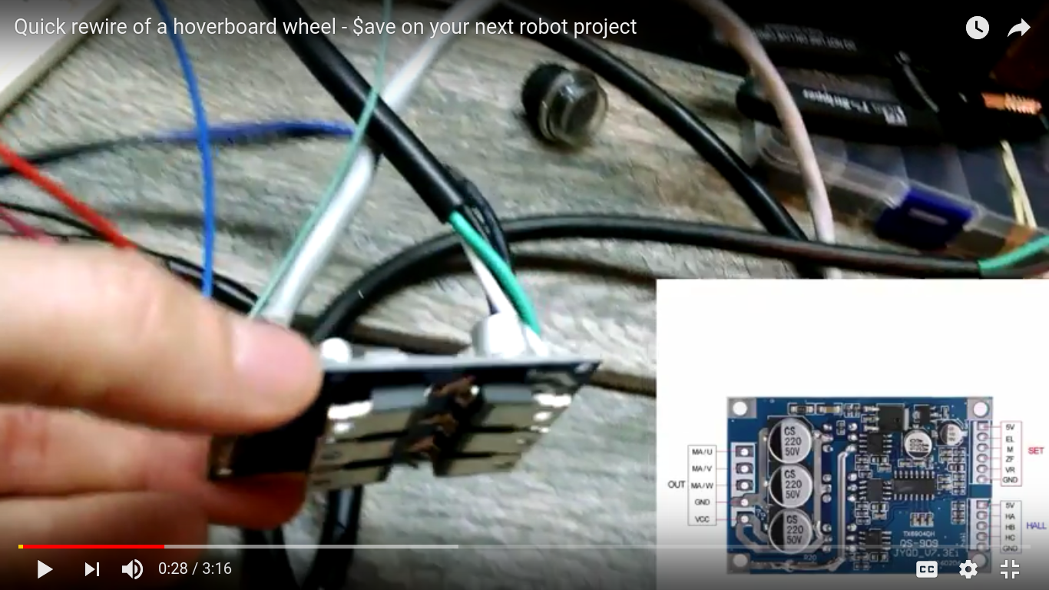

20160222 Wheel Drive Mechanism

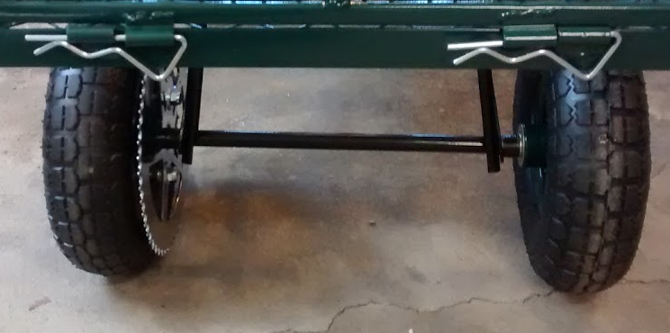

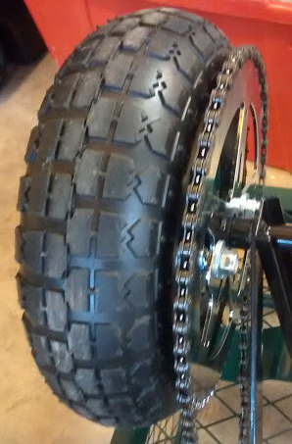

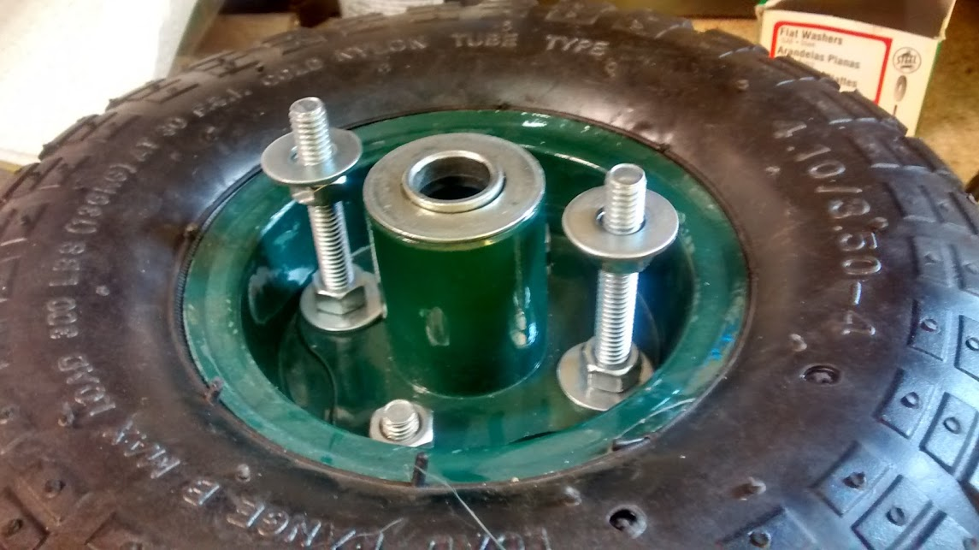

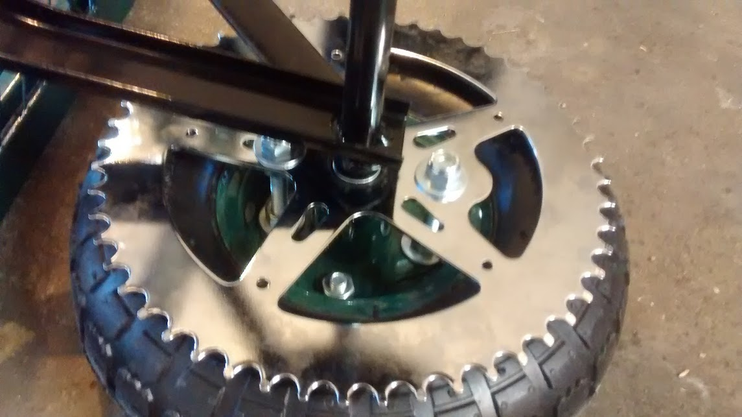

It appears 2 of the 4 bolts will allow a longer bolt to go through the wheel hub and the 52 tooth pully. This would require 2x 13mm x 2.5 inch bolts. Preferably “all thread” to allow a bolt to be directly mounted to the hub (Bolt head on one side of the hub and nut directly on the other side (tightened go stablilize the bolt, which extends another couple of inches)

Actual Used:

2 ea. 5/16 Carriage Bolt x 2.5 inches

2ea 5/16 Nuts

4ea 5/16 nuts (nylon locking)

4ea 5/16 washers

|| | |

----||---- -----|| || -----

| || |xxxxxxxxxxxxxxxxxxxxxxxxxxx| || || |xxxx

| || | | || || |

| || |xxxxxxxxxxxxxxxxxxxxxxxxxxx| || || |xxxx

----||---- |----|| || -----

|| || ||

| |

carriage ^ < bolt threads >

bolt

head

hub ^

nut ^

sprocket

washer washer

nut nut

20150624 Trash Can Transport Robot TCT

# 

8/24/2017 **Due to apparant lack or torque I am changing the chain drive. Going from 52T to 90T and from 12T to 7T. Items are shown below. It looks like 54mm is the standard spacing for wheel mounting bolt separation.**

**Epifany - All this stuff has already been resolved with the zip scooter E100. The motor, sprokets, chains have been designed and implemented. The unit LeRoy had was simply a belt driven version. I happened to run across the chain drive version and all the parts are now available. I can duplicate the E100 drive substituting 80T sprocket which should directly replace the 54mm mounting hole sprocket I currently have (different tooth count and size - original was 54T). By using the “same” drive sprockets/chain as the E100 I should have the same torque (ample to move LeRoy). I will have some reduced torque due to difference in wheel diameter. 8” vs. appx 10”.**

**After finding a sprocket that would give additional torque, I discovered some versions of the Razor E100 (100W motor) use the same chain/sprocket size as the new sprocket AND it appears the original driven sprocket had 54 teeth and the original drive sprocket had 9 teeth giving it a ratio of 6.0 The current ratio is 52/12 = 4.33. With the new driven sprocket (90T) the actual ratio is 90/9 or 10. So we are going from 6.0 to 10.0 gearing. This should give us a significant mechanical advantage but not the 3 we had hoped for. The increase is only 1.66. The difference is we used a 7 tooth sprocket in the previous calculation. (The new motor comes with a 9 tooth sprocket).**

**So let's review:**

**E100 original gearing: 6.0**

**Current TCT gearing: 4.33**

**Proposed TCT gearing: 6.0**

**Mechanical Advantage Improvement: 1.66 but the same mechanical advantage as the original but.....**

**The actual delivered ratio has still not been calculated as the difference in wheel size has not be accounted for.**

**E100 tire size: 8"**

**TCT Tire size: 10"**

**So this decreases our effective gear ratio by .8.**

**So the effective gear ratio is 6 x .8 or 4.8**

**So the effective delivered torque should be 80% of the original delivered torque. Will this be enough to propel the TCT to the top of boot hill. The shadow knows!**

20170727 Upgraded TCT as described above. We converted the TCT to the 25H format (chain and sprockets) giving enchaned torque. The TCT climbed the entire hill with 100 lbs of batteries using 24VDC power.

1. **Mounting holes for the new 90t sprocket had to be redrilled to fit the original drive bolts.**
2. **An additional washer was added to the drive wheel to reduce the wheel/sprocket side to side movement. It is larger than the shaft but smaller than the ring spacer.**

**|| x**

**|| x x**

**xxxxxxxxxxxxxxxxxxxxxxxxxxxxxxxxxxxxxxxxxxxxxxxxxxx|| xxxxxx x x**

**|| --+ x**

**|| +---------**

**|| |**

**|| +---------**

**|| --+ x**

**xxxxxxxxxxxxxxxxxxxxxxxxxxxxxxxxxxxxxxxxxxxxxxxxxxx|| xxxxxx x x**

**|| x x**

**|| x**

100W Motor - 24 Volts (Style: MY6812) Genuine Razor Replacement

In excellent condition with no major Damage but they may have some light cosmetic handling marks.

MY6812 24 Volt, 100 Watt Chain Drive Motor, 2300 RPM, 6.5 Amp, permanent-magnet motor.

* 9 tooth sprocket for #25 chain
* 12 gauge power leads with standard 1/4" push-in connectors.

Motor Dimensions: 2-5/8" wide 3-7/8" long excluding shaft, 4-7/8" long including shaft.

| 25H 80T 54mm Rear Chain Sprocket For 47 49cc Mini Moto Dirt Bike Mini ATV Quad | | |
| --- | --- | --- |

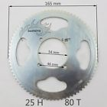

[25H 158 Links Chain For 47/49cc Pocket Bike Mini Moto Quad Dirt ATV Scooter New](http://www.ebay.com/itm/25H-158-Links-Chain-For-47-49cc-Pocket-Bike-Mini-Moto-Quad-Dirt-ATV-Scooter-New/381733816786?ssPageName=STRK%3AMEBIDX%3AIT&_trksid=p2060353.m2749.l2649)

( 381733816786 )

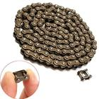

------------------------------------------------------------------------------------

Information from advertisement

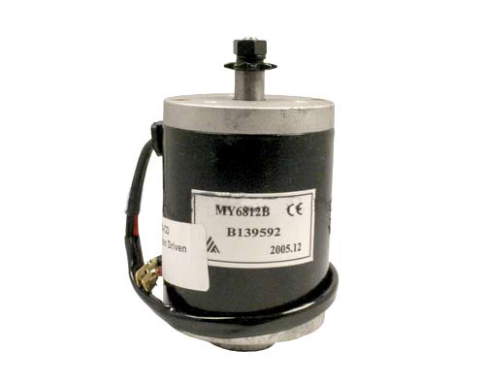9 tooth #25 chain sprocket

100 watt

Multiple compatibility

Left or right rotation by reversing wires

MY6812B motor

This 24 volt 100 watt MY6812 motor with 9 tooth #25 chain sprocket is compatible with the Razor E100, E125, E150, E175, eSpark, and Trikke. This is also the motor used on the Dynacraft Hello Kitty SU E-Scooter as well as the Pulse Charger, EM-1000, Reverb, and Revster electric scooters.

This motor is for chain-drive models of the Razor E100/E125 (versions 5+) and all versions of the Razor E150, E175, and eSpark. Also compatible with the Pulse Reverb and Revster scooters. This motor will not work on belt-drive versions of the Razor E100/E125. Please click [**here**](http://www.monsterscooterparts.com/24v10mowsp.html) if you need the belt-drive motor.

**Note:** Unlike many electric scooter parts, the 100 watt MY6812 electric motor works equally well as part of a 12 volt system as it does in a 24 volt electric system. In addition, this motor is capable of rotation in either the clockwise or counterclockwise direction by reversing the motor's power wires.

------------------------------------------------------------------------------------

| **24V 100W**  for chain drive scooters | **24 Volt 100 Watt Electric Scooter Motor**  24V 100W 2500 RPM electric scooter motor. Powerful two brush permanent magnet design with 100% ball bearing construction. Includes 9 tooth sprocket for #25 chain. 12" long power leads with terminal connectors. Shaft rotation reversible by reversing power leads. Dimensions: 2-5/8" wide x 3-7/8" long excluding shaft, 4-7/8" long including shaft. Made by Unite®.  Item # MOT-24100   | Compatibility: Razor E100 and E125 chain drive scooters plus other similar makes and models. Cross references motor number: MY6812B | | --- | |
| --- | --- | --- |

------------------------------------------------------------------------------------

Compass Navigation

[Hoverboard Motor](http://www.ebay.com/itm/6-5-Self-Balancing-Scooter-Wheel-Tire-Assembly-w-Hub-Motor-UL-2272-Certified-/362022029177?hash=item544a31c779:g:6V8AAOSw~XpZUsmb)

Poo investigiated IR navigation and found it was great for night time operation. It eliminated light sources from unwanted areas, but was not suitable for daytime operation.

**This lead to Compass Navigation-**

3V-5V HMC5883L Triple Axis Compass Magnetometer Sensor Module For Arduino

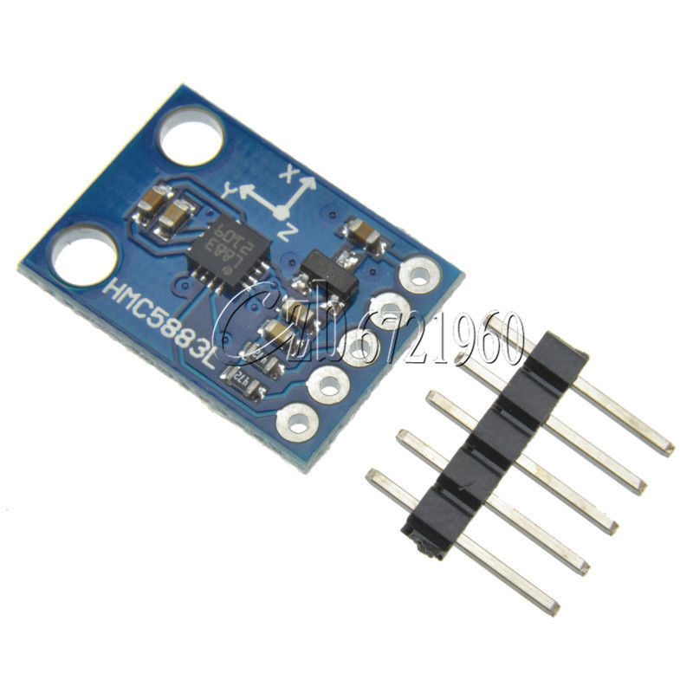

20151030 was the first day of compass navigation. The Bitty Rover was able to travel a relatively straight line for the 100 ft distance.

Variations were noted.

1. near refrigerator
2. near car
3. near the garage door and immediately outside the garage door. (modest 3 or 4 degrees in immediate area).
4. Excellent repeatability (+- 2ft) variation at finish line. Some variation in error was noted with a change in speed. The higher speed (was still slow) tended to be more accurate. **Repeatability is significantly effected if you tilt the compass sensor**. (in this case the compass sensor board was socketed on one end. Moving it off of level affected the direction.

1. 100 ft travel was appx 5 minutes in duration.

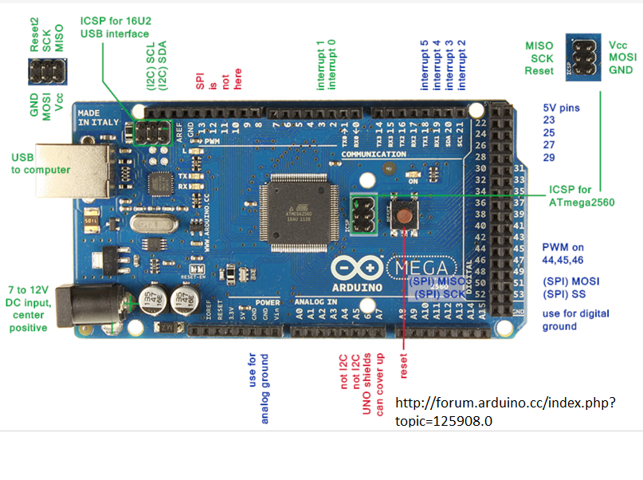

Calculating force to drive the TCT

*The torque required [Nm] at the wheels is Maximum force[N] x radius of the wheel{m]*

*T(wheel) = F x r*

*This has to be converted to the torque required at the machine side, which is a ratio. Ignoring all losses, power in = power out, but one can generally allow for a loss of about 2% therefore,*

*T(motor) x w(motor) = T(wheel) x w(wheel) where T is in Nm and w (angular velocity) is measured in radians per second.*

*To include gearbox efficiency of 98% this becomes*

*0.98 T(motor) x w(motor) = T(wheel) x w(wheel) (you will need more torque at the motor side to overcome the inefficiencies)*

*To convert rpm to radians per second: w = rpm x 2Pi / 60*

*Assume a 9 inch wheel. 9 x 2.54 = D= 22.86 cm C = 3.14 x 22.86 = 71.78 cm*

*Assume a speed of 5 ft/min 5 x 12 x 2.54 /60 = cm/sec = 2.54 cm/sec 1 R = 28.26 Sec*

*Radians/Sec = 2 x 3.14 x 1 / 28.26 =* ***.222 radians/Sec***

*Assume weight of 100 lbs.* ***445 Newtons***

*Direct Drive: T(wheel) = F x r = 445 x .222 = 98.89 Nm*

***Gear Ratio Torque***

***1/1 100Nm***  *= 10Kg*

***1/50 gear ratio 2 Nm 200Ncm***

***1/100 gear ratio: 1 Nm 100Ncm***

***1/200 gear ratio 50Ncm***

***1/500 .05Ncm***

***1/1000 gear ratio: .00099Nm = .099 Ncm***

Required output: 100Nm

Sample motor:

* Rated voltage: DC12V
* No-load speed: 8r/min 2 x 3.14 x /60 = .1 radians/Sec
* Rated torque: 48kg.cm 480Ncm = 4.8Nm
* No-load Current: 0.11A
* Reduction ratio:1/634

Just a couple of pointers, I'm ignoring any inefficiencies in the motor, gearing and friction etc. So, for the object to move, I have the following:

Distance to move object: 0.05 metres (5cm)

Mass of object: 2 KG

Time to move object: 0.06 second Force required to move object:

Mass x 9.8 Force required to move object: 2 x 9.8

Force required to move object: 19.6 newtons

Torque required to move object: Distance (m) x Force (newtons)

Torque required to move object: 0.05 x 19.6

Torque required to move object: 0.98 newton-metres

RPM required to complete distance in time: 60 (seconds per minute) / time to move object RPM required to complete distance in time: 60 / 0.06 RPM required to complete distance in time: 1000 rpm One RPM actually moves the object twice, so halve the RPM: RPM required to complete distance in time: 500 rpm

Reference https://www.physicsforums.com/threads/calculating-the-required-motor-size-to-move-a-load.691669/

Ours:

Just a couple of pointers, I'm ignoring any inefficiencies in the motor, gearing and friction etc. So, for the object to move, I have the following:

Distance to move object: 0.05 metres (5cm)

Mass of object: 45 KG

Time to move object: 1.0 second Force required to move object:

Mass x 9.8 Force required to move object: 45 x 9.8

Force required to move object: 450 newtons

Torque required to move object: Distance (m) x Force (newtons)

Torque required to move object: 20m x 45

Torque required to move object: 900 newton-metres

RPM required to complete distance in time: 60 (seconds per minute) / time to move object RPM required to complete distance in time: 60 / 0.06 RPM required to complete distance in time: 1000 rpm One RPM actually moves the object twice, so halve the RPM: RPM required to complete distance in time: 500 rpm

Reference https://www.physicsforums.com/threads/calculating-the-required-motor-size-to-move-a-load.691669/

100lb = 45 Kg

9 inch wheel = 4.5 inch radius x 2.54 = 6.35

45Kg x R x coefficient of sliding friction ?? .1

Kg x R = 45 x 6.35cm x .1 = 45Kg x 6.35 = 28 Kg cm

Jim’s Motors (2ea)

12V 3 RPM JCY370

**DC3V 6V 12V 24V High Torque 370 Turbo Worm Reduction Gear DC Motor with Gearbox**

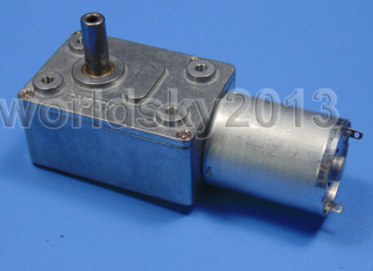

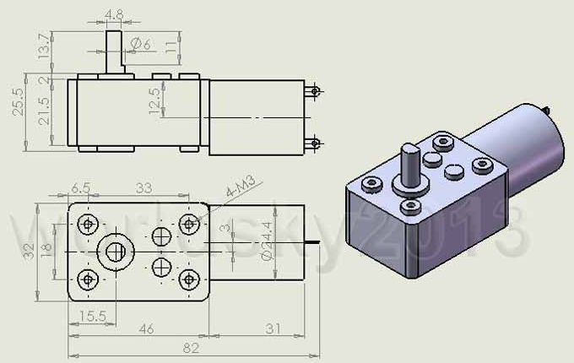

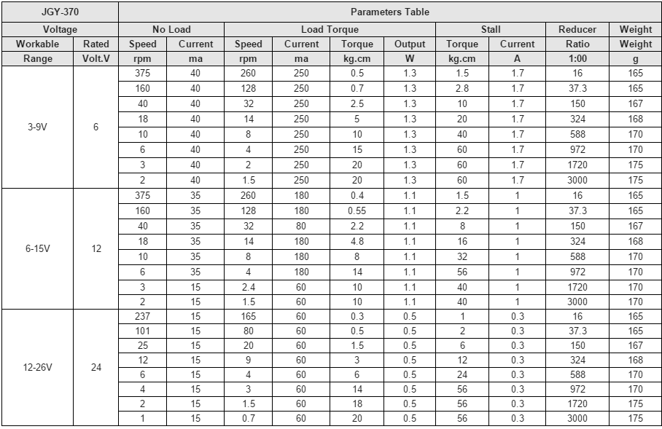

**Wiring of sensors photoresistors:**

(+)------------Sensor-------------[ 3.3K resistor ]-------------- (-)

|

+-----[ 4.K resistor ]-------------- Analog Input

Separate Processors for Safety Circuits

e.g. Lamp Sync Circuit

[ATTINY85 Ultrasonic Distance Sensor](http://www.instructables.com/id/Altoid-Tin-Quiet-Alarm/?ALLSTEPS) (wiring and code)

Prototype TCT Frame

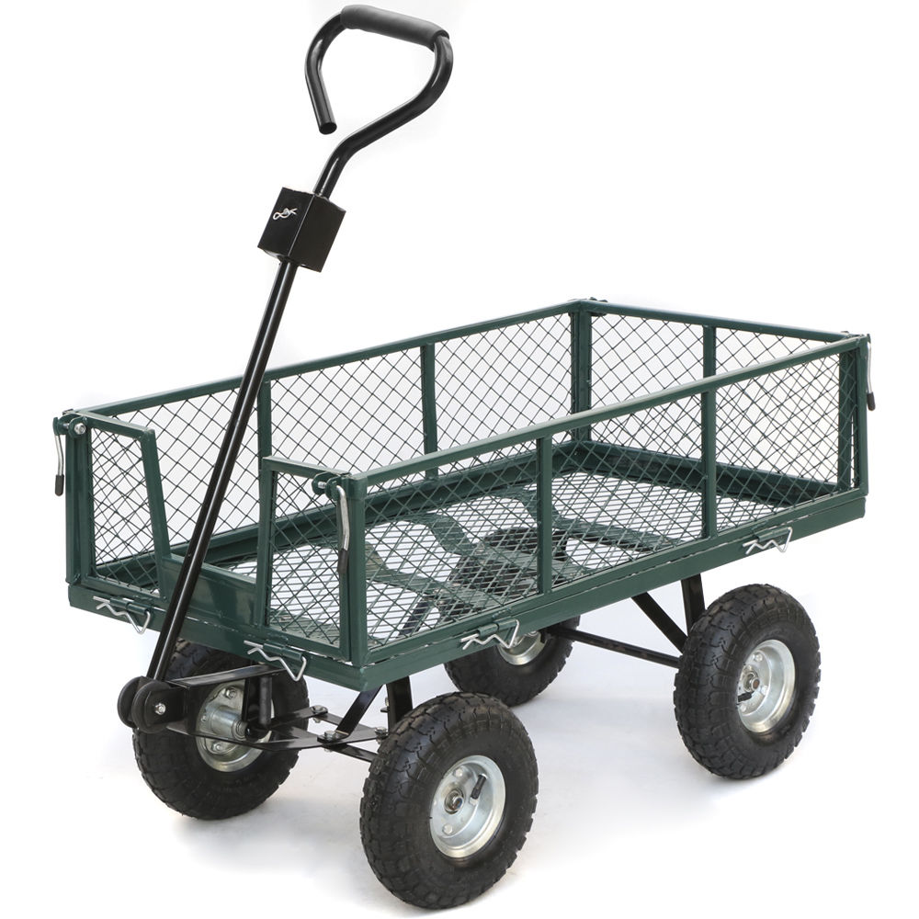

**The Code 12/03/2015 rev 5 (Compass Guidance + Remote Control)**

#include <VirtualWire.h>

//#include <VirtualWire.h> //https://www.pjrc.com/teensy/td_libs_VirtualWire.html

/* Text moved to be bottom of the code in an attempt to drive people crazy.

*

*/

// This code works and gives degrees!!!

#include <Wire.h> // For Compass

#define Addr 0x1E // 7-bit address of HMC5883 compass

float fHeading[9];

int readcount;

float CurrentCourse;

float error;

//Wireless Stuff

byte xval, yval;

signed int x,y;

char hex[9] = {0};

int wirelessActive = 0;

int manualStop = 0;

int leftturnbias = 30;

int rightturnbias = 15;

int debug = 1;

int debugBoost = 0;

int debugInputs = 0;

int debugCompass = 0;

/* 1. Calibrate Optics (has independent loop

* 1 = Run in Raw Mode Compass (raw)

* 2 = cal Guidance

* 3 = cal lamp transition counter

* 4 = transition trender

* 7 = floating source voltage

*/

float TargetHeading = 172.0;

float TargetHeadingA = 172.0;

float TargetHeadingB = 352.0;

int forwardReverse = 1; // 1 Forward 2 Reverse

int maxSteer = 10; // maximum steering boost 5

int speed = 50; //ssssss 38 42

//int forwardReverse = 1; // Forward

int countNoSteer = 0;

const int PWMLPin = 44; // Enable PWM Left Motor

const int PWMRPin = 46; // Enable PWM Right Motor

const int L1Pin = 36; // L1 = Left Motor Lead 1

const int L2Pin = 38; // L2 = Left Motor Lead 2

const int L3Pin = 40; // L3 = Right Motor Lead 1

const int L4Pin = 42; // L4 = Right Motor Lead 2

const int LEDPin = 13; // LED

int inPin24 = 24; // choose the input pin (for a pushbutton)

int val24 = 0; // variable for reading the pin status

const int MaxSpeed = 255; //not yet used, this will be the max speed your motors can drive at (max PWM) and will be used to help correct for differences in motors

const int CorrectLeft = 0; //to be added later, this will attempt to correct for any motor differances in going forward/backward

const int CorrectRight = 0; //to be added later, this will attempt to correct for any motor differances in going forward/backward

int leftcount = 0;

int rightcount = 0;

int leftboost = 1; // left turn boost count

int rightboost = 1; // right turn boost count

int boostCount = 1; // the loop count

int boostDelay = 10; // the boost in incremented by 1 each time the loop counter reaches this number

int state = HIGH; // the current state of the output pin

//int val24; // the current reading from input pin 24

int previous = LOW; // the previous reading from the input pin

// the follow variables are long's because the time, measured in miliseconds,

// will quickly become a bigger number than can be stored in an int.

int time;

long ltime = 0; // the last time the output pin was toggled

long debounce = 200; // the debounce time, increase if the output flickers

void setup() // Built-in initialization block

{

if (debug == 2)

{

speed = .8 * speed;

}

// initialize digital pin 13 as an output.

// pinMode(0, OUTPUT); //

pinMode(1, OUTPUT); //Lamp Signal Transition OFF-> ON

pinMode(2, OUTPUT); //Turn Right

pinMode(3, OUTPUT); //Turn Left

//pinMode(4, OUTPUT); //Speaker

pinMode(5, OUTPUT); //Lamp Signal Lock (Valid Source and Level)

pinMode(6, OUTPUT); //Turn Signal

pinMode(7, OUTPUT); //Wireless Control

pinMode(8, OUTPUT);

pinMode(inPin24, INPUT); // declare pushbutton as input

// START LAMP TEST - Turn ON test of lamps

digitalWrite(2, HIGH); //

digitalWrite(3, HIGH); //

digitalWrite(5, HIGH); //

digitalWrite(6, HIGH); //

digitalWrite(7, HIGH); //

digitalWrite(8, HIGH); //

tone(4, 2900, 500); // Start tone - .5 second

delay(500); // Delay to finish tone

tone(4, 3000, 500); // Start tone - .5 second

delay(500); // Delay to finish tone

pinMode (L1Pin, OUTPUT);

pinMode (L2Pin, OUTPUT);

pinMode (L3Pin, OUTPUT);

pinMode (L4Pin, OUTPUT);

pinMode (PWMLPin, OUTPUT);

pinMode (PWMRPin, OUTPUT);

// END LAMP TEST - Turn off test of lamps

digitalWrite(2, HIGH); //

digitalWrite(3, HIGH); //

digitalWrite(5, HIGH); //

digitalWrite(6, HIGH); //

digitalWrite(7, HIGH); //

digitalWrite(8, HIGH); //

Serial.begin(19200);

Wire.begin();

// Set operating mode to continuous

Wire.beginTransmission(Addr);

Wire.write(byte(0x02));

Wire.write(byte(0x00));

Wire.endTransmission();

//WIRELESS

vw_set_rx_pin(22);

vw_setup(2000);

vw_rx_start();

Serial.println("Hello!");

}

//-----------------------------------------------------------------

//-----------------------------------------------------------------

void loop() // Main loop auto-repeats

{

// delay(900);

if( wirelessActive == 0 && manualStop == 0){

checkinputs();

getcompass();

RunGuidance();

}

getWirelessData();

}

//-----------------------------------------------------------------

float volts(int adPin) // Measures volts at adPin

{ // Returns floating point voltage

return float(analogRead(adPin)) * 5.00 / 1024.00;

}

//-----------------------------------------------------------------

//------------------------------------------------------------------

void beepHigh(int time) //

{

tone(4, 3000, time); // high pitch beep

delay(time);

}

//---------------------------------------------------------------

//---------------------------------------------------------------

void beepLow(int time) // low pitch beep

{

tone(4, 2800, time);

delay(time);

}

//---------------------------------------------------------------

//---------------------------------------------------------------

void beepMulti(int time) // Left turn function

{

//t tone(4, 2800, time); // Play RIGHT sensor sound

//t delay(time); // Delay to finish tone

//t tone(4, 2800, time); // Play RIGHT sensor sound

//t delay(time); // Delay to finish tone

//t tone(4, 2800, time); // Play RIGHT sensor sound

//t delay(time); // Delay to finish tone

}

//-----------------------------------------------------------------

//-----------------------------------------------------------------

void beepLampReached(int time) // Left turn function

{

// THIS CODE KEPT GREEN LIGHT DIM DURNING NORMAL OPERATION??? IN DEBUG 2

// tone(4, 3000, time); // Play high tone for .1 second

// delay(time); // Delay to finish tone

// tone(4, 2800, time); // Play low tone for .1 second

// delay(time);

}

//---------------------------------------------------------

//---------------------------------------------------------

void RunGuidance()

{

// digitalWrite(2, LOW); //

// digitalWrite(3, LOW); //

digitalWrite(5, LOW); //

digitalWrite(6, LOW); //

digitalWrite(7, LOW); //

digitalWrite(8, LOW); //

//// Serial.println(" ");

//// Serial.print("------------------------------------------ ");

//// Serial.print(" COURSE> ");

//// Serial.print(CurrentCourse);

//// Serial.print(" < "); // 640------------------0----------------1360

error = TargetHeading - CurrentCourse;

// mapping to -179 .. 180

if (error <= -180.0) {error = 360.0 - error;}

if (error > 180.0) {error = -360.0 + error ; }

if (error < 0.0) // (Turn LEFT)

{

left();

}

if (error > 0.0) // RIGHT (TURN RIGHT)

{

right();

}

}

//---------------------------------------------------------

//---------------------------------------------------------

void displayDebug(int time)

{

Serial.println(" ");

Serial.print("De: ");

Serial.print(debug);

}

void displayLampCount(int time)

{

}

int forward() //fffffff

{

digitalWrite(2, HIGH); // Turn Right Lamp

digitalWrite(3, HIGH); // Turn Left Lamp

Serial.print(" -FORWARD- ") ;

Serial.print(" ERROR> ");

Serial.print(error);

if (debug == 2 || debug == 2)

{

// beepHigh(50);

Serial.print("--------NL<<<<>>>>> TURN STRAIGHT: ");

// Serial.print(voltsL);

// Serial.print(" R: ");

// Serial.print(voltsR);

// Serial.print(" Min V Set: ");

// Serial.print(minValidVoltageSetpoint);

// Serial.print(" Lock: ");

// Serial.print(lampSignalLock);

}

digitalWrite(L1Pin, 0);

digitalWrite(L2Pin, 1);

digitalWrite(L3Pin, 0);

digitalWrite(L4Pin, 1);

analogWrite(PWMLPin, speed + 5);

analogWrite(PWMRPin, speed);

}

void right() //rrrrrrrr

{

//// Serial.print(" -TURN RIGHT- ") ;

//// Serial.print(" ERROR> ");

//// Serial.print(error);

digitalWrite(3, LOW); // (turn off Green lamp)

digitalWrite(2, HIGH); // Left Lamp ON (Red) (Turn Right).

if (debug == 2 || debug == 2)

{

// beepHigh(50);

//// Serial.print("--------NL<<<<<<< TURN LEFT: ");

}

if (rightboost == 1)

{

countleft();

}

digitalWrite(L1Pin, 0);

digitalWrite(L2Pin, 1);

digitalWrite(L3Pin, 0);

digitalWrite(L4Pin, 1);

analogWrite(PWMLPin, speed + 5); //Offset for this motor

analogWrite(PWMRPin, speed + rightturnbias + leftcount);

}

void left() //llllllllll

{

//// Serial.print(" -TURN LEFT- ");

//// Serial.print(" ERROR> ");

//// Serial.print(error);

digitalWrite(2, LOW); // (turn off Right lamp)

digitalWrite(3, HIGH); // Right Lamp On - Green (turn left)

if (debug == 2 || debug == 2)

{

// beepLow(100);

Serial.print("-------NR>>>>>>> TURN LEFT : ");

}

if (leftboost == 1)

{

countright();

}

digitalWrite(L1Pin, 0);

digitalWrite(L2Pin, 1);

digitalWrite(L3Pin, 0);

digitalWrite(L4Pin, 1);

analogWrite(PWMLPin, speed + leftturnbias + rightcount);

analogWrite(PWMRPin, speed);

}

void leftb()

{

digitalWrite(L1Pin, 1);

digitalWrite(L2Pin, 0);

digitalWrite(L3Pin, 1);

digitalWrite(L4Pin, 0);

analogWrite(PWMLPin, speed + 15);

analogWrite(PWMRPin, speed + 0);

digitalWrite(3, HIGH); // Turn Left Lamp

if (debug == 2 || debug == 2)

{

// beepHigh(50);

Serial.print("--------<<<<<<< TURN LEFT L: ");

}

}

void rightb() {

digitalWrite(2, HIGH); // Turn Right Lamp

digitalWrite(L1Pin, 1);

digitalWrite(L2Pin, 0);

digitalWrite(L3Pin, 1);

digitalWrite(L4Pin, 0);

analogWrite(PWMLPin, speed + 0);

analogWrite(PWMRPin, speed + 15);

if (debug == 2 || debug == 2)

{

// beepLow(100);

Serial.print("------->>>>>>> TURN RIGHT Volts L: ");

// Serial.print(voltsL);

Serial.print(" R: ");

// Serial.print(voltsR);

Serial.print(" Min V Set: ");

// Serial.println(minValidVoltageSetpoint);

}

}

int allstop()

{

digitalWrite(2, LOW); // (turn off Right lamp)

digitalWrite(3, LOW); // (turn off Green lamp)

digitalWrite(L1Pin, 0);

digitalWrite(L2Pin, 0);

digitalWrite(L3Pin, 0);

digitalWrite(L4Pin, 0);

analogWrite(PWMLPin, 0);

analogWrite(PWMRPin, 0);

// delay(500);

}

int backward()

{

digitalWrite(L1Pin, 1);

digitalWrite(L2Pin, 0);

digitalWrite(L3Pin, 1);

digitalWrite(L4Pin, 0);

analogWrite(PWMLPin, speed);

analogWrite(PWMRPin, speed);

}

void countright()

{

if(debugBoost == 1){

Serial.println(" ");

Serial.println(" --------CountRight---boostDelay---boostCount-----rightCount--");

Serial.print(boostDelay);

Serial.print(" ");

Serial.print(boostCount);

Serial.print(" ");

Serial.print(rightcount);

}

leftcount=0;

if (boostDelay > boostCount)

{

boostCount = ++boostCount;

}

else

{

boostCount = 0;

rightcount= ++rightcount;

}

if (rightcount > maxSteer)

{

rightcount = maxSteer;

// allstop();

// exit;

}

}

void countleft()

{

rightcount = 0;

if(debugBoost == 1){

Serial.println(" ");

Serial.println(" --------CountLeft---boostDelay---boostCount-----rightCount--");

Serial.print(boostDelay);

Serial.print(" ");

Serial.print(boostCount);

Serial.print(" ");

Serial.print(leftcount);

}

if (boostDelay > boostCount)

{

boostCount = ++boostCount;

}

else

{

boostCount = 0;

leftcount= ++leftcount; }

if (leftcount > maxSteer)

{

leftcount = maxSteer;

// allstop();

// exit;

}

}

void checkinputs() ///// iiiiiiiiiiiiiiiiiiiiii

{

// if the input just went from LOW and HIGH and we've waited long enough

// to ignore any noise on the circuit, toggle the output pin and remember

// the time

val24 = digitalRead(inPin24); // read input value

if (val24 == HIGH && previous == LOW && millis() - ltime > debounce)

{

if (state == HIGH)

state = LOW;

else

state = HIGH;

ltime = millis();

}

digitalWrite(6, state);

previous = val24;

if (state == HIGH)

{ // check if the input is HIGH (button released)

digitalWrite(6, LOW); // turn LED OFF

Serial.print(" INPUT LOW : ");

TargetHeading = TargetHeadingB;

}

if (state == LOW)

{

digitalWrite(6, HIGH); // turn LED ON

if(debugInputs == 1){

Serial.print(" INPUT HIGH : ");

}

TargetHeading = TargetHeadingA;

}

if(debugCompass == 1){

Serial.print(" ");

Serial.print(TargetHeading);

Serial.print(" ");

}

}

void getcompass()

{

readcount = readcount + 1;

if (readcount > 2)

{

readcount = 0;

}

int x, y, z;

// Initiate communications with compass

Wire.beginTransmission(Addr);

Wire.write(byte(0x03)); // Send request to X MSB register

Wire.endTransmission();

Wire.requestFrom(Addr, 6); // Request 6 bytes; 2 bytes per axis

if(Wire.available() <=6) { // If 6 bytes available

x = Wire.read() << 8 | Wire.read();

z = Wire.read() << 8 | Wire.read();

y = Wire.read() << 8 | Wire.read();

}

// If compass module lies flat on the ground with no tilt,

// just x and y are needed for calculation

float heading=atan2(x, y)/0.0174532925;

if(heading < 0) heading+=360;

heading=360-heading; // N=0/360, E=90, S=180, W=270

fHeading[readcount] = heading;

heading = fHeading[0] + fHeading[2] + fHeading[3] + fHeading[4];

heading = heading + fHeading[5] + fHeading[6] + fHeading[7] + fHeading[8];

heading = heading + fHeading[5];

heading = heading/2 ;

if(debugInputs == 1){

Serial.println(heading);

}

CurrentCourse = heading;

//// delay(1);

}

void getWirelessData()

{

uint8_t buf[VW_MAX_MESSAGE_LEN];

uint8_t buflen = VW_MAX_MESSAGE_LEN;

if (vw_get_message(buf, &buflen)) {

int i;

for (i = 0; i<buflen; i++) {

hex[i]=buf[i];

}

}

sscanf(hex, "%02X%02X %02d%02d", &xval, &yval, &x, &y);

// if (x == 0 && y == 0) {

// bot.Speed(0,0);

// bot.stop();

// }

//// Serial.println("----x------ ");

//// Serial.print(x);

//// Serial.print(" ");

//// Serial.print(xval);

//// Serial.print(" ");

//// Serial.print(y);

//// Serial.print(" ");

//// Serial.print(yval);

if (x == 1 && xval == 0) {

right();

}

if (x == -1 && xval == 0) {

left();

}

if (x == 0 && y == 1) {

forward();

}

if (x == 0 && y == -1) {

allstop();

manualStop = 1;

TargetHeading = CurrentCourse;

}

wirelessActive = 1;

digitalWrite(7, HIGH); // Wireless Active

if (x==0 && xval==0 && y==0){

wirelessActive = 0;

digitalWrite(7, LOW); //

}

}

/* Move toward the light

*

* Wiring for Bitty Rover connections L298 to Mega

* 1. violet 46 A enable (first wire from power side)

* 2. orange 40 In 1

* 3. blue 42 In 2

* 4. brown 36 In 3

* 5. yellow 38 In 4

* 6. green 44 B enable

*

* 9/22 --------------------------------------------------------

* 11/20 completed transition to compass control.

* control works any any direction.

* added pushbutton toggle to toggle between2 directions.

* Note: Coming close to parked automobile can be fatal, causing an extreme course variation.

* 11/22 boost bugs corrected. Adjusted bias on left trun (needed to be more agressive).

* Added "Forward" to remote control;

* Added "Stop" to remote control. (this stops the rover and allows remote control only after the stop. (compass stuff is disabled).

* Added "remote control" indicator lamp (7)

*

*/

**The Code 11/22/2015 rev 4 (Compass Guidance + Remote Control)**

#include <VirtualWire.h>

/* Text moved to be bottom of the code in an attempt to drive people crazy.

*

*/

//#include <VirtualWire.h> //https://www.pjrc.com/teensy/td_libs_VirtualWire.html

// This code works and gives degrees!!!

#include <Wire.h>

#define Addr 0x1E // 7-bit address of HMC5883 compass

float fHeading[9];

int readcount;

float CurrentCourse;

float error;

//Wireless

byte xval, yval;

signed int x,y;

char hex[9] = {0};

int wirelessActive = 0;

int manualStop = 0;

int debug = 1;

/* 1. Calibrate Optics (has independent loop

* 1 = Run in Raw Mode Compass (raw)

* 2 = cal Guidance

* 3 = cal lamp transition counter

* 4 = transition trender

* 7 = floating source voltage

*/

float TargetHeading = 172.0;

float TargetHeadingA = 172.0;

float TargetHeadingB = 352.0;

int forwardReverse = 1; // 1 Forward 2 Reverse

int maxSteer = 10; // maximum steering boost 5

int speed = 50; //ssssss 38 42

//int forwardReverse = 1; // Forward

int countNoSteer = 0;

const int PWMLPin = 44; // Enable PWM Left Motor

const int PWMRPin = 46; // Enable PWM Right Motor

const int L1Pin = 36; // L1 = Left Motor Lead 1

const int L2Pin = 38; // L2 = Left Motor Lead 2

const int L3Pin = 40; // L3 = Right Motor Lead 1

const int L4Pin = 42; // L4 = Right Motor Lead 2

const int LEDPin = 13; // LED

int inPin24 = 24; // choose the input pin (for a pushbutton)

int val24 = 0; // variable for reading the pin status

const int MaxSpeed = 255; //not yet used, this will be the max speed your motors can drive at (max PWM) and will be used to help correct for differences in motors

const int CorrectLeft = 0; //to be added later, this will attempt to correct for any motor differances in going forward/backward

const int CorrectRight = 0; //to be added later, this will attempt to correct for any motor differances in going forward/backward

int leftcount = 0;

int rightcount = 0;

int leftboost = 1;

int rightboost = 1;

int boostCount = 1;

int boostDelay = 5; // Delay boost by this loop counts

int state = HIGH; // the current state of the output pin

//int val24; // the current reading from input pin 24

int previous = LOW; // the previous reading from the input pin

// the follow variables are long's because the time, measured in miliseconds,

// will quickly become a bigger number than can be stored in an int.

int time;

long ltime = 0; // the last time the output pin was toggled

long debounce = 200; // the debounce time, increase if the output flickers

void setup() // Built-in initialization block

{

if (debug == 2)

{

speed = .8 * speed;

}

// initialize digital pin 13 as an output.

// pinMode(0, OUTPUT); //

pinMode(1, OUTPUT); //Lamp Signal Transition OFF-> ON

pinMode(2, OUTPUT); //Turn Right

pinMode(3, OUTPUT); //Turn Left

//pinMode(4, OUTPUT); //Speaker

pinMode(5, OUTPUT); //Lamp Signal Lock (Valid Source and Level)

pinMode(6, OUTPUT); //Turn Signal

pinMode(7, OUTPUT); //Wireless Control

pinMode(8, OUTPUT);

pinMode(inPin24, INPUT); // declare pushbutton as input

// START LAMP TEST - Turn ON test of lamps

digitalWrite(2, HIGH); //

digitalWrite(3, HIGH); //

digitalWrite(5, HIGH); //

digitalWrite(6, HIGH); //

digitalWrite(7, HIGH); //

digitalWrite(8, HIGH); //

tone(4, 2900, 500); // Start tone - .5 second

delay(500); // Delay to finish tone

tone(4, 3000, 500); // Start tone - .5 second

delay(500); // Delay to finish tone

pinMode (L1Pin, OUTPUT);

pinMode (L2Pin, OUTPUT);

pinMode (L3Pin, OUTPUT);

pinMode (L4Pin, OUTPUT);

pinMode (PWMLPin, OUTPUT);

pinMode (PWMRPin, OUTPUT);

// sensorBalance = volts(A3) / volts(A0) ;

// END LAMP TEST - Turn off test of lamps

digitalWrite(2, LOW); //

digitalWrite(3, LOW); //

digitalWrite(5, LOW); //

digitalWrite(6, LOW); //

digitalWrite(7, LOW); //

digitalWrite(8, LOW); //

Serial.begin(19200);

Wire.begin();

// Set operating mode to continuous

Wire.beginTransmission(Addr);

Wire.write(byte(0x02));

Wire.write(byte(0x00));

Wire.endTransmission();

//WIRELESS

vw_set_rx_pin(22);

vw_setup(2000);

vw_rx_start();

Serial.println("Hello!");

}

//-----------------------------------------------------------------

//-----------------------------------------------------------------

void loop() // Main loop auto-repeats

{

// delay(900);

if( wirelessActive == 0 && manualStop == 0){

checkinputs();

getcompass();

RunGuidance();

}

getWirelessData();

}

//-----------------------------------------------------------------

float volts(int adPin) // Measures volts at adPin

{ // Returns floating point voltage

return float(analogRead(adPin)) * 5.00 / 1024.00;

}

//-----------------------------------------------------------------

//------------------------------------------------------------------

void beepHigh(int time) //

{

tone(4, 3000, time); // high pitch beep

delay(time);

}

//---------------------------------------------------------------

//---------------------------------------------------------------

void beepLow(int time) // low pitch beep

{

tone(4, 2800, time);

delay(time);

}

//---------------------------------------------------------------

//---------------------------------------------------------------

void beepMulti(int time) // Left turn function

{

//t tone(4, 2800, time); // Play RIGHT sensor sound

//t delay(time); // Delay to finish tone

//t tone(4, 2800, time); // Play RIGHT sensor sound

//t delay(time); // Delay to finish tone

//t tone(4, 2800, time); // Play RIGHT sensor sound

//t delay(time); // Delay to finish tone

}

//-----------------------------------------------------------------

//-----------------------------------------------------------------

void beepLampReached(int time) // Left turn function

{

// THIS CODE KEPT GREEN LIGHT DIM DURNING NORMAL OPERATION??? IN DEBUG 2

// tone(4, 3000, time); // Play high tone for .1 second

// delay(time); // Delay to finish tone

// tone(4, 2800, time); // Play low tone for .1 second

// delay(time);

}

//---------------------------------------------------------

//---------------------------------------------------------

void RunGuidance()

{

// digitalWrite(2, LOW); //

// digitalWrite(3, LOW); //

digitalWrite(5, LOW); //

digitalWrite(6, LOW); //

digitalWrite(7, LOW); //

digitalWrite(8, LOW); //

Serial.println(" ");

Serial.print("------------------------------------------ ");

Serial.print(" COURSE> ");

Serial.print(CurrentCourse);

Serial.print(" < "); // 640------------------0----------------1360

error = TargetHeading - CurrentCourse;

// mapping to -179 .. 180

if (error <= -180.0) {error = 360.0 - error;}

if (error > 180.0) {error = -360.0 + error ; }

if (error < 0.0) // (Turn LEFT)

{

left();

}

if (error > 0.0) // RIGHT (TURN RIGHT)

{

right();

}

}

//---------------------------------------------------------

//---------------------------------------------------------

void displayDebug(int time)

{

Serial.println(" ");

Serial.print("De: ");

Serial.print(debug);

}

void displayLampCount(int time)

{

}

int forward() //fffffff

{

digitalWrite(2, HIGH); // Turn Right Lamp

digitalWrite(3, HIGH); // Turn Left Lamp

Serial.print(" -FORWARD- ") ;

Serial.print(" ERROR> ");

Serial.print(error);

if (debug == 2 || debug == 2)

{

// beepHigh(50);

Serial.print("--------NL<<<<>>>>> TURN STRAIGHT: ");

// Serial.print(voltsL);

// Serial.print(" R: ");

// Serial.print(voltsR);

// Serial.print(" Min V Set: ");

// Serial.print(minValidVoltageSetpoint);

// Serial.print(" Lock: ");

// Serial.print(lampSignalLock);

}

digitalWrite(L1Pin, 0);

digitalWrite(L2Pin, 1);

digitalWrite(L3Pin, 0);

digitalWrite(L4Pin, 1);

analogWrite(PWMLPin, speed + 5);

analogWrite(PWMRPin, speed);

}

void right() //rrrrrrrr

{

Serial.print(" -TURN RIGHT- ") ;

Serial.print(" ERROR> ");

Serial.print(error);

digitalWrite(3, LOW); // (turn off Green lamp)

digitalWrite(2, HIGH); // Left Lamp ON (Red) (Turn Right).

if (debug == 2 || debug == 2)

{

// beepHigh(50);

Serial.print("--------NL<<<<<<< TURN LEFT: ");

}

if (rightboost == 1)

{

countleft();

}

digitalWrite(L1Pin, 0);

digitalWrite(L2Pin, 1);

digitalWrite(L3Pin, 0);

digitalWrite(L4Pin, 1);

analogWrite(PWMLPin, speed + 5); //Offset for this motor

analogWrite(PWMRPin, speed + 15 + leftcount);

}

void left() //llllllllll

{

Serial.print(" -TURN LEFT- ");

Serial.print(" ERROR> ");

Serial.print(error);

digitalWrite(2, LOW); // (turn off Right lamp)

digitalWrite(3, HIGH); // Right Lamp On - Green (turn left)

if (debug == 2 || debug == 2)

{

// beepLow(100);

Serial.print("-------NR>>>>>>> TURN LEFT : ");

}

if (leftboost == 1)

{

countright();

}

digitalWrite(L1Pin, 0);

digitalWrite(L2Pin, 1);

digitalWrite(L3Pin, 0);

digitalWrite(L4Pin, 1);

analogWrite(PWMLPin, speed + 30 + rightcount);

analogWrite(PWMRPin, speed);

}

void leftb()

{

digitalWrite(L1Pin, 1);

digitalWrite(L2Pin, 0);

digitalWrite(L3Pin, 1);

digitalWrite(L4Pin, 0);

analogWrite(PWMLPin, speed + 15);

analogWrite(PWMRPin, speed + 0);

digitalWrite(3, HIGH); // Turn Left Lamp

if (debug == 2 || debug == 2)

{

// beepHigh(50);

Serial.print("--------<<<<<<< TURN LEFT L: ");

}

}

void rightb() {

digitalWrite(2, HIGH); // Turn Right Lamp

digitalWrite(L1Pin, 1);

digitalWrite(L2Pin, 0);

digitalWrite(L3Pin, 1);

digitalWrite(L4Pin, 0);

analogWrite(PWMLPin, speed + 0);

analogWrite(PWMRPin, speed + 15);

if (debug == 2 || debug == 2)

{

// beepLow(100);

Serial.print("------->>>>>>> TURN RIGHT Volts L: ");

// Serial.print(voltsL);

Serial.print(" R: ");

// Serial.print(voltsR);

Serial.print(" Min V Set: ");

// Serial.println(minValidVoltageSetpoint);

}

}

int allstop()

{

digitalWrite(2, LOW); // (turn off Right lamp)

digitalWrite(3, LOW); // (turn off Green lamp)

digitalWrite(L1Pin, 0);

digitalWrite(L2Pin, 0);

digitalWrite(L3Pin, 0);

digitalWrite(L4Pin, 0);

analogWrite(PWMLPin, 0);

analogWrite(PWMRPin, 0);

// delay(500);

}

int backward()

{

digitalWrite(L1Pin, 1);

digitalWrite(L2Pin, 0);

digitalWrite(L3Pin, 1);

digitalWrite(L4Pin, 0);

analogWrite(PWMLPin, speed);

analogWrite(PWMRPin, speed);

}

void countright()

{

Serial.println(" ");

Serial.println(" --------CountRight---boostDelay---boostCount-----rightCount--");

Serial.print(boostDelay);

Serial.print(" ");

Serial.print(boostCount);

Serial.print(" ");

Serial.print(rightcount);

leftcount=0;

if (boostDelay > boostCount)

{

boostCount = ++boostCount;

}

else

{

boostCount = 0;

rightcount= ++rightcount;

}

if (rightcount > maxSteer)

{

rightcount = maxSteer;

// allstop();

// exit;

}

}

void countleft()

{

rightcount = 0;

Serial.println(" ");

Serial.println(" --------CountLeft---boostDelay---boostCount-----rightCount--");

Serial.print(boostDelay);

Serial.print(" ");

Serial.print(boostCount);

Serial.print(" ");

Serial.print(leftcount);

if (boostDelay > boostCount)

{

boostCount = ++boostCount;

}

else

{

boostCount = 0;

leftcount= ++leftcount; }

if (leftcount > maxSteer)

{

leftcount = maxSteer;

// allstop();

// exit;

}

}

void checkinputs() ///// iiiiiiiiiiiiiiiiiiiiii

{

// if the input just went from LOW and HIGH and we've waited long enough

// to ignore any noise on the circuit, toggle the output pin and remember

// the time

val24 = digitalRead(inPin24); // read input value

if (val24 == HIGH && previous == LOW && millis() - ltime > debounce)

{

if (state == HIGH)

state = LOW;

else

state = HIGH;

ltime = millis();

}

digitalWrite(6, state);

previous = val24;

if (state == HIGH)

{ // check if the input is HIGH (button released)

digitalWrite(6, LOW); // turn LED OFF

Serial.print(" INPUT LOW : ");

TargetHeading = TargetHeadingB;

}

if (state == LOW)

{

digitalWrite(6, HIGH); // turn LED ON

Serial.print(" INPUT HIGH : ");

TargetHeading = TargetHeadingA;

}

Serial.print(" ");

Serial.print(TargetHeading);

Serial.print(" ");

}

void getcompass()

{

readcount = readcount + 1;

if (readcount > 2)

{

readcount = 0;

}

int x, y, z;

// Initiate communications with compass

Wire.beginTransmission(Addr);

Wire.write(byte(0x03)); // Send request to X MSB register

Wire.endTransmission();

Wire.requestFrom(Addr, 6); // Request 6 bytes; 2 bytes per axis

if(Wire.available() <=6) { // If 6 bytes available

x = Wire.read() << 8 | Wire.read();

z = Wire.read() << 8 | Wire.read();

y = Wire.read() << 8 | Wire.read();

}

// If compass module lies flat on the ground with no tilt,

// just x and y are needed for calculation

float heading=atan2(x, y)/0.0174532925;

if(heading < 0) heading+=360;

heading=360-heading; // N=0/360, E=90, S=180, W=270

fHeading[readcount] = heading;

heading = fHeading[0] + fHeading[2] + fHeading[3] + fHeading[4];

heading = heading + fHeading[5] + fHeading[6] + fHeading[7] + fHeading[8];

heading = heading + fHeading[5];

heading = heading/2 ;

Serial.println(heading);

CurrentCourse = heading;

delay(1);

}

void getWirelessData()

{

uint8_t buf[VW_MAX_MESSAGE_LEN];

uint8_t buflen = VW_MAX_MESSAGE_LEN;

if (vw_get_message(buf, &buflen)) {

int i;

for (i = 0; i<buflen; i++) {

hex[i]=buf[i];

}

}

sscanf(hex, "%02X%02X %02d%02d", &xval, &yval, &x, &y);

// if (x == 0 && y == 0) {

// bot.Speed(0,0);

// bot.stop();

// }

Serial.println("----x------ ");

Serial.print(x);

Serial.print(" ");

Serial.print(xval);

Serial.print(" ");

Serial.print(y);

Serial.print(" ");

Serial.print(yval);

if (x == 1 && xval == 0) {

right();

}

if (x == -1 && xval == 0) {

left();

}

if (x == 0 && y == 1) {

forward();

}

if (x == 0 && y == -1) {

allstop();

manualStop = 1;

}

wirelessActive = 1;

digitalWrite(7, HIGH); // Wireless Active

if (x==0 && xval==0 && y==0){

wirelessActive = 0;

digitalWrite(7, LOW); //

}

}

/* Move toward the light

*

* Wiring for Bitty Rover connections L298 to Mega

* 1. violet 46 A enable (first wire from power side)

* 2. orange 40 In 1

* 3. blue 42 In 2

* 4. brown 36 In 3

* 5. yellow 38 In 4

* 6. green 44 B enable

*

* 9/22 --------------------------------------------------------

* 11/20 completed transition to compass control.

* control works any any direction.

* added pushbutton toggle to toggle between2 directions.

* Note: Coming close to parked automobile can be fatal, causing an extreme course variation.

* 11/22 boost bugs corrected. Adjusted bias on left trun (needed to be more agressive).

* Added "Forward" to remote control;

* Added "Stop" to remote control. (this stops the rover and allows remote control only after the stop. (compass stuff is disabled).

* Added "remote control" indicator lamp (7)

*

*/

**The Code 11/20/2015 rev 3 (Compass Guidance)**

/* Text moved to be bottom of the code in an attempt to drive people crazy.

*

*/

// This code works and gives degrees!!!

#include <Wire.h>

#define Addr 0x1E // 7-bit address of HMC5883 compass

float fHeading[9];

int readcount;

float CurrentCourse;

float CorrectedCurrentCourse;

float CorrectedTargetHeading;

float error;

int Ierror;

int debug = 1;

/* 1. Calibrate Optics (has independent loop

* 1 = Run in Raw Mode Compass (raw)

* 2 = cal Guidance

* 3 = cal lamp transition counter

* 4 = transition trender

* 7 = floating source voltage

*/

float TargetHeading = 170.0;

float TargetHeadingA = 170.0;

float LeftTurnLimitLow = 0.0;

float LeftTurnLimitHigh = 0.0;

float RightTurnLimitLow = 0.0;

float RightTurnLimitHigh = 0.0;

float TargetHeadingB = 350.0;

int forwardReverse = 1; // 1 Forward 2 Reverse

int maxCalLoop = 8; // max atteps to try one sensor balalnce value

int maxSteer = 5; // maximum steering boost

int speed = 50; //ssssss 38 42

//int forwardReverse = 1; // Forward

int countNoSteer = 0;

const int PWMLPin = 44; // Enable PWM Left Motor

const int PWMRPin = 46; // Enable PWM Right Motor

const int L1Pin = 36; // L1 = Left Motor Lead 1

const int L2Pin = 38; // L2 = Left Motor Lead 2

const int L3Pin = 40; // L3 = Right Motor Lead 1

const int L4Pin = 42; // L4 = Right Motor Lead 2

const int LEDPin = 13; // LED

int inPin12 = 12; // choose the input pin (for a pushbutton)

int val12 = 0; // variable for reading the pin status

const int MaxSpeed = 255; //not yet used, this will be the max speed your motors can drive at (max PWM) and will be used to help correct for differences in motors

const int CorrectLeft = 0; //to be added later, this will attempt to correct for any motor differances in going forward/backward

const int CorrectRight = 0; //to be added later, this will attempt to correct for any motor differances in going forward/backward

int leftcount = 0;

int rightcount = 0;

int leftboost = 0;

int rightboost = 1;

int boostCount = 1;

int boostDelay = 5; // Delay boost by this loop counts

int state = HIGH; // the current state of the output pin

//int val12; // the current reading from input pin 12

int previous = LOW; // the previous reading from the input pin

// the follow variables are long's because the time, measured in miliseconds,

// will quickly become a bigger number than can be stored in an int.

long time = 0; // the last time the output pin was toggled

long debounce = 200; // the debounce time, increase if the output flickers

void setup() // Built-in initialization block

{

if (debug == 2)

{

speed = .8 * speed;

}

// initialize digital pin 13 as an output.

// pinMode(0, OUTPUT); //

pinMode(1, OUTPUT); //Lamp Signal Transition OFF-> ON

pinMode(2, OUTPUT); //Turn Right

pinMode(3, OUTPUT); //Turn Left

//pinMode(4, OUTPUT); //Speaker

pinMode(5, OUTPUT); //Lamp Signal Lock (Valid Source and Level)

pinMode(6, OUTPUT); //Turn Signal

pinMode(7, OUTPUT);

pinMode(8, OUTPUT);

pinMode(inPin12, INPUT); // declare pushbutton as input

// START LAMP TEST - Turn ON test of lamps

digitalWrite(2, HIGH); //

digitalWrite(3, HIGH); //

digitalWrite(5, HIGH); //

digitalWrite(6, HIGH); //

digitalWrite(7, HIGH); //

digitalWrite(8, HIGH); //

tone(4, 2900, 500); // Start tone - .5 second

delay(500); // Delay to finish tone

tone(4, 3000, 500); // Start tone - .5 second

delay(500); // Delay to finish tone

pinMode (L1Pin, OUTPUT);

pinMode (L2Pin, OUTPUT);

pinMode (L3Pin, OUTPUT);

pinMode (L4Pin, OUTPUT);

pinMode (PWMLPin, OUTPUT);

pinMode (PWMRPin, OUTPUT);

// sensorBalance = volts(A3) / volts(A0) ;

// END LAMP TEST - Turn off test of lamps

digitalWrite(2, LOW); //

digitalWrite(3, LOW); //

digitalWrite(5, LOW); //

digitalWrite(6, LOW); //

digitalWrite(7, LOW); //

digitalWrite(8, LOW); //

Serial.begin(19200);

Wire.begin();

// Set operating mode to continuous

Wire.beginTransmission(Addr);

Wire.write(byte(0x02));

Wire.write(byte(0x00));

Wire.endTransmission();

// checkinputs();

}

//-----------------------------------------------------------------

//-----------------------------------------------------------------

void loop() // Main loop auto-repeats

{

if (debug == 1)

{

getRawSensor(10);

getcompass();

checkinputs();

}

}

//-----------------------------------------------------------------

float volts(int adPin) // Measures volts at adPin

{ // Returns floating point voltage

return float(analogRead(adPin)) * 5.00 / 1024.00;

}

//-----------------------------------------------------------------

//------------------------------------------------------------------

void beepHigh(int time) //

{

tone(4, 3000, time); // high pitch beep

delay(time);

}

//---------------------------------------------------------------

//---------------------------------------------------------------

void beepLow(int time) // low pitch beep

{

tone(4, 2800, time);

delay(time);

}

//---------------------------------------------------------------

//---------------------------------------------------------------

void beepMulti(int time) // Left turn function

{

//t tone(4, 2800, time); // Play RIGHT sensor sound

//t delay(time); // Delay to finish tone

//t tone(4, 2800, time); // Play RIGHT sensor sound

//t delay(time); // Delay to finish tone

//t tone(4, 2800, time); // Play RIGHT sensor sound

//t delay(time); // Delay to finish tone

}

//-----------------------------------------------------------------

//-----------------------------------------------------------------

void beepLampReached(int time) // Left turn function

{

// THIS CODE KEPT GREEN LIGHT DIM DURNING NORMAL OPERATION??? IN DEBUG 2

// tone(4, 3000, time); // Play high tone for .1 second

// delay(time); // Delay to finish tone

// tone(4, 2800, time); // Play low tone for .1 second

// delay(time);

}

//---------------------------------------------------------

//---------------------------------------------------------

void getRawSensor(int time)

{

digitalWrite(2, LOW); //

digitalWrite(3, LOW); //

digitalWrite(5, LOW); //

digitalWrite(6, LOW); //

digitalWrite(7, LOW); //

digitalWrite(8, LOW); //

Serial.println(" ");

Serial.print("------------------------------------------ ");

Serial.print(" COURSE> ");

Serial.print(CurrentCourse);

Serial.print(" < "); // 640------------------0----------------1360

error = TargetHeading - CurrentCourse;

// mapping to -179 .. 180

if (error <= -180.0) {error = 360.0 - error;}

if (error > 180.0) {error = -360.0 + error ; }

if (error < 0.0) // (Turn LEFT)

{

left();

Serial.print(" -TURN LEFT- ");

Serial.print(" ERROR> ");

Serial.print(error);

}

if (error > 0.0) // RIGHT (TURN RIGHT)

{

right();

Serial.print(" -TURN RIGHT- ") ;

Serial.print(" ERROR> ");

Serial.print(error);

}

}

//---------------------------------------------------------

//---------------------------------------------------------

void displayDebug(int time)

{

Serial.println(" ");

Serial.print("De: ");

Serial.print(debug);

}

void displayLampCount(int time)

{

}

int forward() //fffffff

{

// lampSignalLock=1; ////temp

digitalWrite(2, HIGH); // Turn Right Lamp

digitalWrite(3, HIGH); // Turn Left Lamp

if (debug == 2 || debug == 2)

{

// beepHigh(50);

Serial.print("--------NL<<<<>>>>> TURN STRAIGHT: ");

// Serial.print(voltsL);

// Serial.print(" R: ");

// Serial.print(voltsR);

// Serial.print(" Min V Set: ");

// Serial.print(minValidVoltageSetpoint);

// Serial.print(" Lock: ");

// Serial.print(lampSignalLock);

}

digitalWrite(L1Pin, 0);

digitalWrite(L2Pin, 1);

digitalWrite(L3Pin, 0);

digitalWrite(L4Pin, 1);

analogWrite(PWMLPin, speed);

analogWrite(PWMRPin, speed);

}

void right() //rrrrrrrr

{

// lampSignalLock=1; ////temp

digitalWrite(2, HIGH); // Turn Left on (Turn Right).

if (debug == 2 || debug == 2)

{

// beepHigh(50);

Serial.print("--------NL<<<<<<< TURN LEFT: ");

}

if (rightboost == 1)

{

countright();

}

digitalWrite(L1Pin, 0);

digitalWrite(L2Pin, 1);

digitalWrite(L3Pin, 0);

digitalWrite(L4Pin, 1);

analogWrite(PWMLPin, speed + 5); //Offset for this motor

analogWrite(PWMRPin, speed + 15 + leftcount);

}

void left() //rrrrrrrrrrrrr

{

// lampSignalLock=1; ////temp

digitalWrite(3, HIGH); // Turn Right Lamp On (turn left)

if (debug == 2 || debug == 2)

{

// beepLow(100);

Serial.print("-------NR>>>>>>> TURN LEFT : ");

}

if (leftboost == 1)

{

countleft();

}

digitalWrite(L1Pin, 0);

digitalWrite(L2Pin, 1);

digitalWrite(L3Pin, 0);

digitalWrite(L4Pin, 1);

analogWrite(PWMLPin, speed + 15 + rightcount);

analogWrite(PWMRPin, speed);

}

void leftb()

{

digitalWrite(L1Pin, 1);

digitalWrite(L2Pin, 0);

digitalWrite(L3Pin, 1);

digitalWrite(L4Pin, 0);

analogWrite(PWMLPin, speed + 15);

analogWrite(PWMRPin, speed + 0);

digitalWrite(3, HIGH); // Turn Left Lamp

if (debug == 2 || debug == 2)

{

// beepHigh(50);

Serial.print("--------<<<<<<< TURN LEFT L: ");

}

}

void rightb() {

digitalWrite(2, HIGH); // Turn Right Lamp

digitalWrite(L1Pin, 1);

digitalWrite(L2Pin, 0);

digitalWrite(L3Pin, 1);

digitalWrite(L4Pin, 0);

analogWrite(PWMLPin, speed + 0);

analogWrite(PWMRPin, speed + 15);

if (debug == 2 || debug == 2)

{

// beepLow(100);

Serial.print("------->>>>>>> TURN RIGHT Volts L: ");

// Serial.print(voltsL);

Serial.print(" R: ");

// Serial.print(voltsR);

Serial.print(" Min V Set: ");

// Serial.println(minValidVoltageSetpoint);

}

}

int allstop()

{

digitalWrite(L1Pin, 0);

digitalWrite(L2Pin, 0);

digitalWrite(L3Pin, 0);

digitalWrite(L4Pin, 0);

analogWrite(PWMLPin, 0);

analogWrite(PWMRPin, 0);

// delay(500);

}

int backward()

{

digitalWrite(L1Pin, 1);

digitalWrite(L2Pin, 0);

digitalWrite(L3Pin, 1);

digitalWrite(L4Pin, 0);

analogWrite(PWMLPin, speed);

analogWrite(PWMRPin, speed);

}

int countright()

{

leftcount=0;

if (boostDelay > boostCount)

{

boostCount = ++boostCount;

rightcount= ++rightcount;

}

else

{

boostCount = 0;

}

if (rightcount > maxSteer)

{

rightcount = maxSteer;

allstop();

exit;

}

}

int countleft()

{

rightcount = 0;

if (boostDelay > boostCount)

{

boostCount = ++boostCount;

leftcount= ++leftcount;

}

else

{

boostCount = 0;

}

if (leftcount > maxSteer)

{

leftcount = maxSteer;

allstop();

exit;

}

}

void checkinputs() ///// iiiiiiiiiiiiiiiiiiiiii

{

// if the input just went from LOW and HIGH and we've waited long enough

// to ignore any noise on the circuit, toggle the output pin and remember

// the time

val12 = digitalRead(inPin12); // read input value

if (val12 == HIGH && previous == LOW && millis() - time > debounce)

{

if (state == HIGH)

state = LOW;

else

state = HIGH;

time = millis();

}

digitalWrite(6, state);

previous = val12;

if (state == HIGH)

{ // check if the input is HIGH (button released)

digitalWrite(6, LOW); // turn LED OFF

// Serial.print(" INPUT LOW : ");

TargetHeading = TargetHeadingB;

}

if (state == LOW)

{

digitalWrite(6, HIGH); // turn LED ON

// Serial.print(" INPUT HIGH : ");

TargetHeading = TargetHeadingA;

}

Serial.print(TargetHeading);

}

void getcompass()

{

readcount = readcount + 1;

if (readcount > 2)

{

readcount = 0;

}

int x, y, z;

// Initiate communications with compass

Wire.beginTransmission(Addr);

Wire.write(byte(0x03)); // Send request to X MSB register

Wire.endTransmission();

Wire.requestFrom(Addr, 6); // Request 6 bytes; 2 bytes per axis

if(Wire.available() <=6) { // If 6 bytes available

x = Wire.read() << 8 | Wire.read();

z = Wire.read() << 8 | Wire.read();

y = Wire.read() << 8 | Wire.read();

}

// If compass module lies flat on the ground with no tilt,

// just x and y are needed for calculation

float heading=atan2(x, y)/0.0174532925;

if(heading < 0) heading+=360;

heading=360-heading; // N=0/360, E=90, S=180, W=270

fHeading[readcount] = heading;

heading = fHeading[0] + fHeading[2] + fHeading[3] + fHeading[4];

heading = heading + fHeading[5] + fHeading[6] + fHeading[7] + fHeading[8];

heading = heading + fHeading[5];

heading = heading/2 ;

Serial.println(heading);

CurrentCourse = heading;

delay(1);

}

/* Move toward the light

*

* Wiring for Bitty Rover connections L298 to Mega

* 1. violet 46 A enable (first wire from power side)

* 2. orange 40 In 1

* 3. blue 42 In 2

* 4. brown 36 In 3

* 5. yellow 38 In 4

* 6. green 44 B enable

*

* 9/22 --------------------------------------------------------

* 11/20 completed transition to compass control.

* control works any any direction.

* added pushbutton toggle to toggle between2 directions.

* Note: Coming close to parked automobile can be fatal, causing an extreme course variation.

*/

HISTORICAL INFORMATION ON OPTICAL OPTION

For phase 1 you really only need to prove a guidance capability (direct).

1. Verify you can sense direction and adjust left/right accurately from 0 to 100 ft.

Photo transistors, optics, uno, light source.

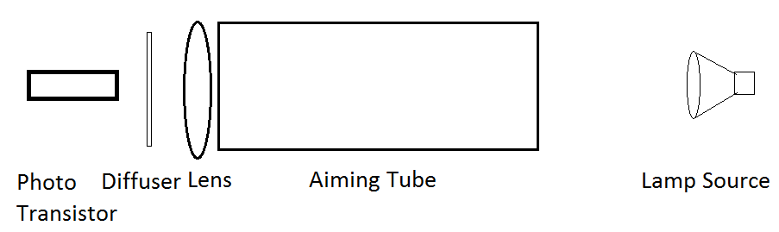

2. Enhance guidance for use of the reflected light method. Verify good signal to noise ratio.

3. Modulate the source lamp and confirm good signal to noise ratio (and interlock).

4. Use incremental encoder to determine travel distance.

5. Use ultrasonic sensor to sense objects for safety.

6. Implement the smurf link for remote control.

Parts on order (NOT TESTED)



| ORDER DATE  Jun 21, 2015 | ORDER TOTAL  US $4.00  Free shipping |
| --- | --- |

1 item sold by[cici10086](http://www.ebay.com/usr/cici10086?_trksid=p2060353.m2749.l2754)

| [Photodiode Light Sensor Module 3.3-5V Input Light Sensor Arduino Raspberry pi](http://www.ebay.com/usr/cici10086?_trksid=p2060353.m2749.l2754)  [**Photodiode Light Sensor Module 3.3-5V Input Light Sensor Arduino Raspberry pi**](http://www.ebay.com/usr/cici10086?_trksid=p2060353.m2749.l2754)  [Photodiode Light Sensor Module 3.3-5V Input Light Sensor Arduino Raspberry pi](http://www.ebay.com/itm/271899422024?_trksid=p2060353.m2749.l2649&ssPageName=STRK%3AMEBIDX%3AIT)  Quantity: 4  not used with TCT (so far) | ITEM PRICE:  US $1.00 |
| --- | --- |

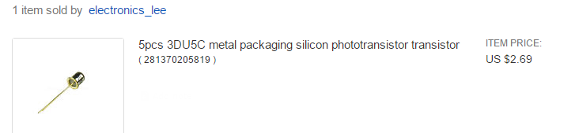

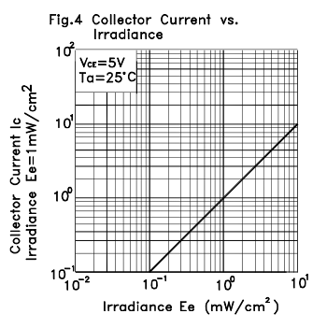

**20Pcs Photo Light Sensitive Resistor Inductor 5516 GL5516 Photoelectric Switch (ebay)**

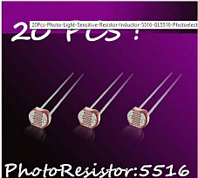 [GL5516 Manual](http://akizukidenshi.com/download/ds/senba/GL55%20Series%20Photoresistor.pdf)

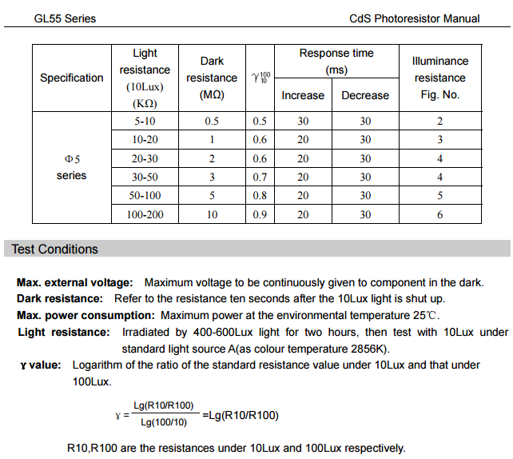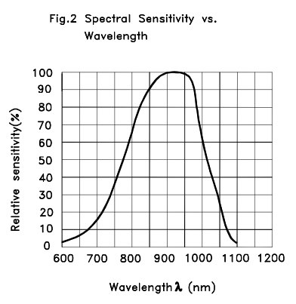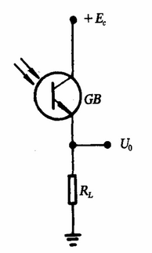

[3DU5C Spec Sheet](https://www.kingbrightusa.com/images/catalog/spec/WP3DP3BT.pdf)

TESTING PHASE (FOOLIN ROUND)

**CONSTRUCTION AND THEORY OF THE OPTICAL DEVICE(S)**

Update 8/17/2017

I build a sleeve using black plastic sheet and glue the lens on the end. (I tape the cylinder to hold the cylinder together). A slightly larger tube made from the same plastic sheet is made such that the first tube will easily slide within it. The outer tube is then mounted to the desired device and cut to length (to reduce incidental light - length should reflect target range/size). Plastic sheet was from a cheap 8.5x11 booklet cover/binder (walmart)

Poo Bah’s Disclaimer - Poo ain’t no optical genius. His prowess in this area was derived from developing a trigger system for amatuer horse race timers. It did work, but he makes no claims of actual knowledge in this field.

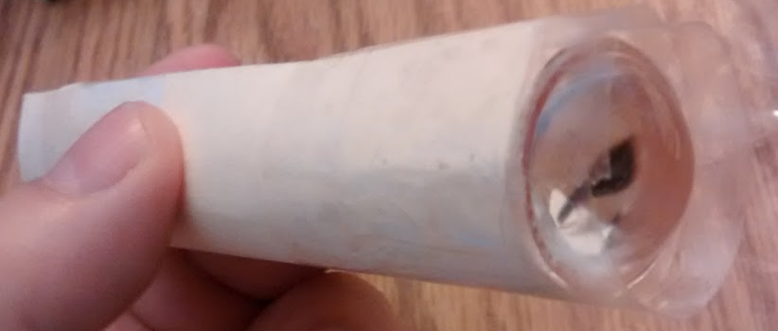

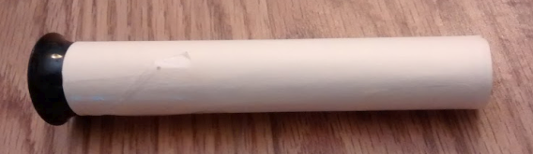

There are two optical lenses were tested here.

One is a simple 10x jewelers glass.

The other is a simple convex lens.

Both are placed in the end of the aiming tube. (the tube was simply a piece of manilla folder cut to make it. (Later you will paint it black to prevent light from entering through the sides of the tube).

To quote the Grand Poo Bah (improves your “signal to noise ratio”). Seems “signal to noise ratio” is wedged between his two brain cells (two is optimistic!).

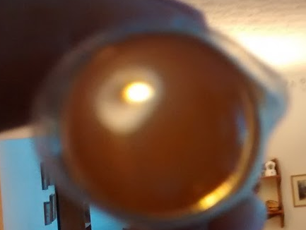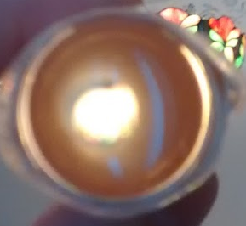

If you look through the tube you can see the lamp source (here, a tiffiny style lamp).

At close range the light fills end to the tube.

(too close to use this to guide your robot with a single optical device- all you see is light).

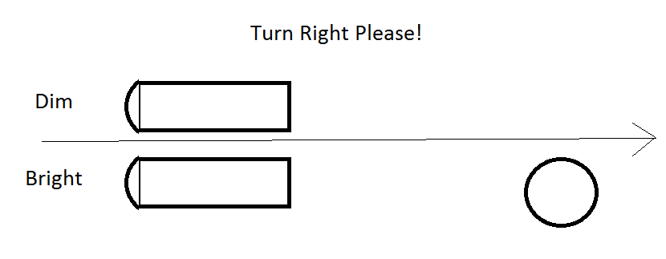

At a further distance you can see the light as a portion of the viewing area.(now you are talkin).

As the light moves away from your focal area the light striking the photo transistor weakens and your processor recognises it is time to turn the robot toward the light, but which way is toward the light (we could be pointed to the left or right of the light). Well, that is where Poo Bah shows some form of intelligence (this is probably and exxageration). Bah has opted to use two optical devices such that if the left lamp dims and the right lamp gets brighter, hey you must be drifting left. It is time to turn rightward (see sketch below). Of course bah has oversimplified everyting to make this easy and modular (having such a keene mind and all). All we need to know is Right High, Left Low means turn right.

What else is going on in Bah’s mind (used the term loosely)? Well we probably want to take a moving average of the “difference” between the two optical devices. We must also track the ambient light level (are we having a solar flare?). It would be nice to modulate the light source and confirm our light source is the right one. The last idea is one we would expect from such a sick mind. Poo says we should consider controlling the light source in such a way that it could be use to transfer information to the robot (e.g. you are approaching the base station) or “I don’t see you”. Enough of this balderdash.

3W Infrared LED Lamp

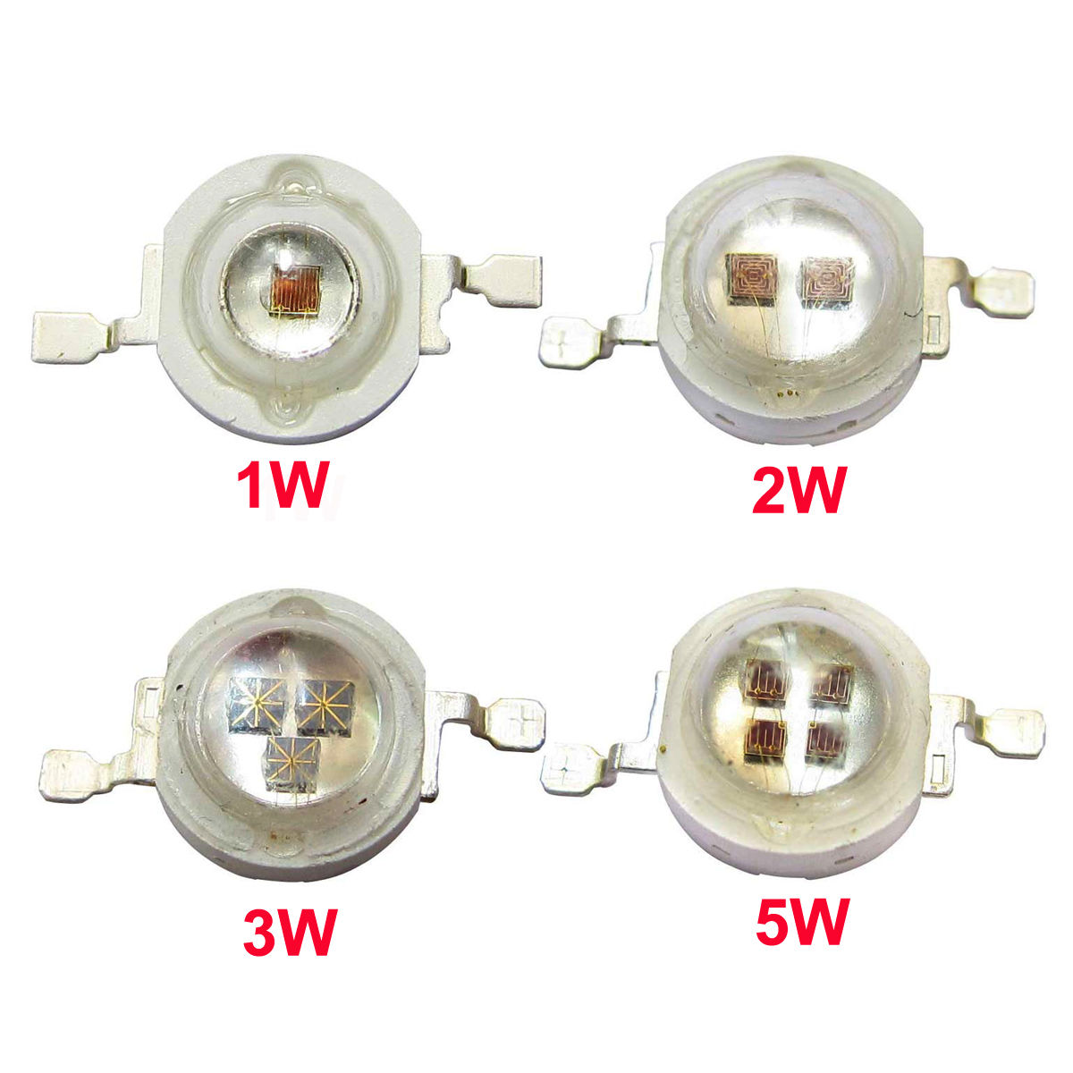

**3W**

-Forward Voltage: 1.6~1.7Vdc

-Forward Current:900~1050mA

-Wave length: 940nm~945nm

-Life Span: >50,000 Hours

-Working temperature: >-20° <+60°

-Beam angle: 120 degrees.

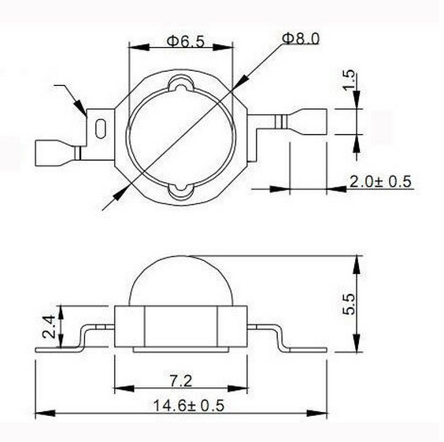

**Wiring of sensors photoresistors:**

PRELIMINARY TEST FOR ROBOT CONTROL

This testing was done on a parallax robot (on loan from Leroy).

Parallax does have some good totorials.

First is [Parallax Run for 3 seconds](http://learn.parallax.com/node/217). Works fine from 5V usb source.

(While this is servo driven, it should entertain Bah for a few minutes).

[Parallax Infrared Navigation](http://learn.parallax.com/node/307)

[Parallax Whisker Control (servo commands)](http://learn.parallax.com/node/241)

[Parallax Servo Control Command Curve](http://learn.parallax.com/node/207)

Jim’s TCT prototype THE MOVIE!

[First Successful Attempt](https://goo.gl/photos/wHMKKXkKCtRmidNW9)

Source Lamp

The source lamp is not modulated with a square using the following circuit:

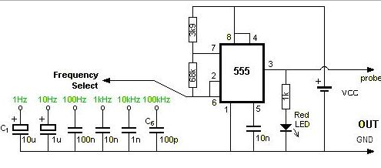

I am using a 1 UF cap probably running about 3 hz currently. Updated to .5 mfd oil filled capacitor running maybe 50 hz. The output (marked probe here) is driving a FET power transistor (did not have a 2n3055 at that point). A 1k ohm resistor to the base should work for you.

out (probe) goes to base of the transistor thru the 1k ohm resistor. The collector goes to the negative lead of your LED lamp (12W in my case). The positive lead of the lamp goes to 12V Vcc. Put 12V on the ne555 to as shown with a battery. I got the led blinking first then connected the power LED (motorcycle lamp).

**Pre production sensors:**

This will be an attempt to develop sensors using simple standard hardware with nothing that would be difficult to do. The goal is to make this as precise as possible without making it difficult. The precision required is minimal, but we do want to do what is easily accomplished. Cut pieces square. Make reasonable attempt to do right angles. Try to get the sensor in the center of the pipe.

We are starting here with 1 inch schedule 40 pipe (cheap and straight). We are using ¾ inch pipe here with an ¾ inch end cap. I cut the 2 pieces using a miter saw. The pipes and end caps were painted flat black (block light from tubes and reduce reflections).

The original testing sensors were 134 mm when extened to the operating position. (from end or tube to back parth of sensor.

The pre production tubes were cut to 137 mm (additional length can be cut off). The length was reduced to 118.5 in step 2. Also the end cap can add a max of ~20 mm. The ¾ inch schedule 40 end cap (from Lowes) is numbered 02466 and the 4 appears to be dead center.

Sensor diameter ~ 4.8mm. (about 9/64 inch).

lead to lead distance (outside) 4.2 mm (about 9/64 inch).

**Assembly of End Cap:**

This is the instructions for 1 sensor (you will need two).

*Assembly is not critical, just try to get the sensor centered with the surface perpendicular to the pipe. Recessing the sensor will help protect it from being banged by the optical lens.*

Drill at 3/16 in hole in the center of the end. Slip insulation removed from phone style wire over the two leads of the photo resistive sensor to prevent sorting leaving about ¼” bare for soldering.

From the inside of the end cap, insert the insulated leads of the sensor insuring the sensor surface sits below the surface. Insure the sensor is perpindicular to the center of the pipe. The sensor should fit snugly in the hole.

(In this step, be carefull not to get glue on the sensor surface). Insert glue in the outside end of the hole to help secure the insulated wires.

Attach 1 ft. of wire to each lead using solder. This wire should be somewhat flexible. (Using 4 lead male/male breadboard ribbon cable would be ideal in this case (2 leads going to each sensor). On this version I used 30AWG tin plated copper wire wrap wire (what I have). Cover the solder joints with electrical tape or head shrink.

Cut a breadboard jumper into two pieces and strip ¼ inch from both pieces. Solder the jumpers to each wire and cover with electrical tape or heat shrink. (this will connect the sensors to the breadboard).